AGUILAR, Kryzha Lei P. December 8, 2019

GARCIA, Neil Fritz S. ECE2112

2 – ECE – E

**PROOF OF TESTING**

*(Problem 5 - Python)*

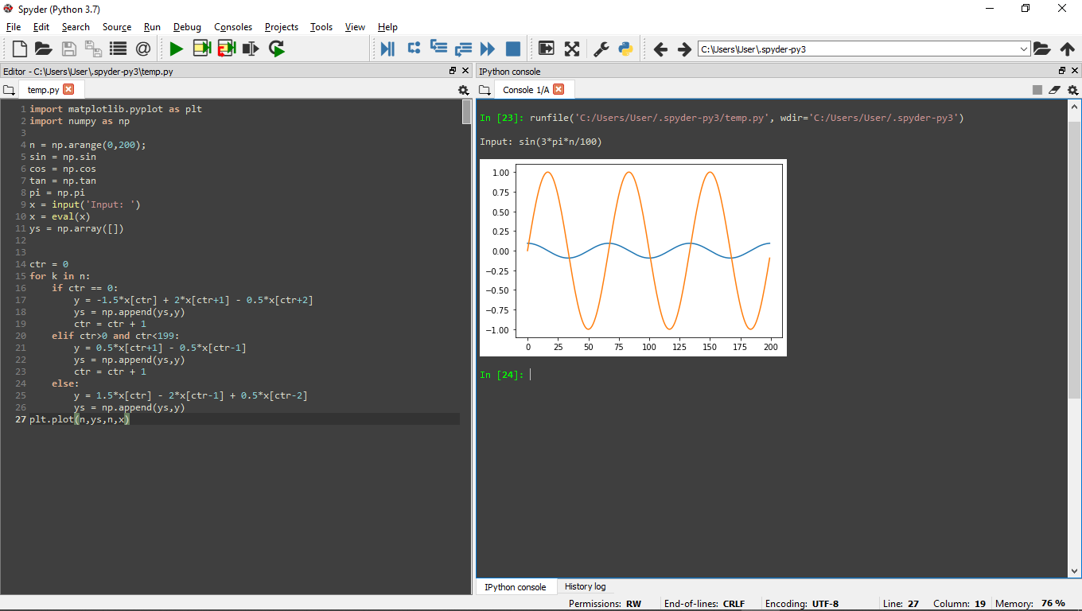***Code:***

***Testing:***